UX Criteria in Technology Evaluation Framework

Version 2.0
24 October 2017

Compiled and Written by
Sunil Kumar Das
HUE IT Team
Bangalore, India

Edited by
Joseph Nearhouse
HUE IT Team
Morris Plains, New Jersey

UX Criteria in Technology Evaluation Framework

- Introduction – What is Technology Evaluation?
- Who Performs Technology Evaluation?
- Defining a Standard Technology Evaluation Process
- Incorporating UX in the Technology Evaluation Process
- Conclusion

Introduction – What is Technology Evaluation?

Technology Evaluation is a set of principles, methods, techniques, and tools for effectively assessing the potential value of a technology and how well it fits within an organization. It is one of the most significant methodologies for driving innovation and technology transfer. It can be utilized in screening new ideas, assessing new products, developing new technology, and implementing new solutions.

Technology Evaluation is best understood as a process for analyzing various technologies that may provide new information and capabilities to help organizations achieve their goals. The outcome is a thorough evaluation that helps determine which technologies are the best and most appropriate from a technical, market, and consumer perspective.

Who Performs Technology Evaluation?

Technical Specialists, Fellows, Architects, and Product Managers are key individuals who identify, test, evaluate, and recommend new technologies that are most appropriate for organizational needs and requirements throughout the Technology Evaluation Framework.

In order to keep pace with advancements in technology and rapidly changing organizational needs, these individuals require a well-defined evaluation process that is efficient, effective, repeatable, and as objective as possible.

At Honeywell, the Technical Specialists, Fellows, Architects, and Product Managers leverage self-defined standards and checklists to determine the best organizational fit. However, the IT HUE Team has observed that there is no specifically defined or published process that is available for the evaluators to reference during the Technology Evaluation Framework.

Upon this observation, the IT HUE Team collected Observational Voice of Customer (OVOC) from 18 evaluators in order to document and analyze their evaluation process and criteria. Their insights help standardize the Technology Evaluation Framework and ensure that the User Experience is always being considered.

Defining a Standard Technology Evaluation Process

The Technology Evaluation Framework is generally followed with these guidelines in mind:

- Technology Readiness
- Technology Maturity
- Platform and Core Development
- Cleanliness of the Development Code
- Suppliers of the Technology
- Cost of Lifetime Ownership
- Support Backbone and Training Requirements
- Ability to Customize based on Organization Needs
- Maintenance and Reproducibility
- Ease of User and Adoption

In addition to these guidelines, User Experience should also be a key consideration while evaluating technologies to ensure they provide value to real users within the organization.

However, research conducted by the IT HUE Team shows that there is no standard process for Technology Evaluation throughout Honeywell. And while the guidelines listed above are followed, there is an opportunity to define a standard Technology Evaluation Process for all.

The 4-phase Technology Evaluation Process suggested by the IT HUE Team is shown below:

- Exploration
- Evaluation
- Experimentation
- Finalization

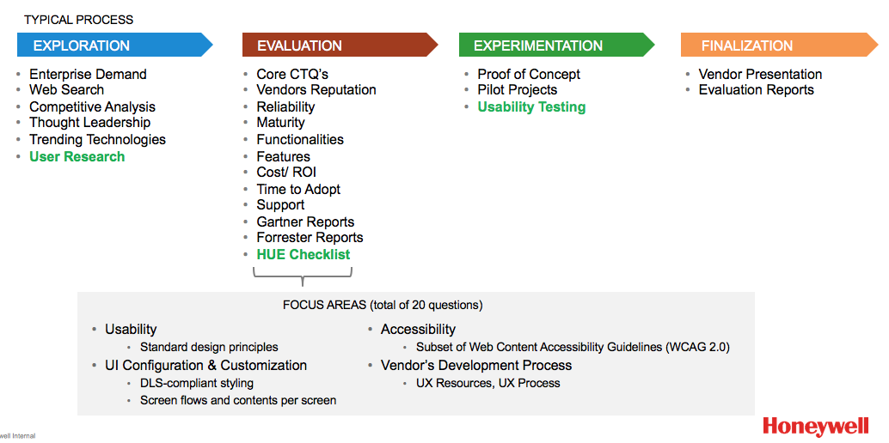

Incorporating UX in the Technology Evaluation Process

Without a strong User Experience, users of new software may use the software incorrectly or, most likely, refuse to use the software at all. This will result in poor software adoption and negatively impacts KPIs that the software was intended to improve in the first place.

The key components of strong User Experience within software are outlined below:

- Learnability - How quickly can users to learn to perform common tasks?
- Efficiency - How quickly and effectively can users perform common tasks?
- Memorability - How quickly can users remember and establish proficiency?
- Errors - How often do users commit errors and how quickly do they recover?
- Satisfaction - How pleasant or enjoyable is the software to use?

These key components of UX must be considered within the Technology Evaluation Process. In addition, other parameters of UX like accessibility, usability, and desirability should also be considered when evaluating new technologies, products, and software.

But how do we ensure that each of these UX factors is being considered? Some methods for considering UX within the 4-phase Technology Evaluation Process are shown below:

Exploration Phase – Conduct User Research to understand the user’s needs, touch points, and pain points. Define and prioritize the users with a Stakeholder Mapping Exercise. These needs can then be compared to the new technologies out-of-the-box functionality.

Evaluation Phase – Utilize the HUE Vendor Checklist which outlines what to be aware of when evaluating certain technologies, software, or vendors. This is an effective tool for comparing multiple options against each other. The HUE Vendor Checklist is available for download on the IT HUE Portal Resource Page.

Experimentation Phase – Conduct Usability Testing with targeted users to ensure the technology or software meets their needs and achieves a high System Usability Score (SUS) which measures the usefulness, usability, and desirability of the technology or software. Information on Usability Testing is also available on the IT HUE Portal Resource Page.

Finalization Phase – Distribute surveys to target users after the technology has been launched to ensure the technology or software is meeting their expectations. Ask for feedback on how the technology could be improved and use that feedback to prioritize future improvement opportunities.

Conclusion

Technology Evaluation is a crucial activity for ensuring that Honeywell’s technology and software offerings remain contemporary and continue to add value for users.

Throughout this article, we have discussed who performs the Technology Evaluation Framework and the guidelines they follow in doing so. We have identified a gap in the standardization of the Technology Evaluation Framework and recommended a 4-Phase Technology Evaluation Process to be leveraged throughout the organization.

Finally, we have discussed how User Experience impacts the Technology Evaluation Framework and provided recommendations on how to incorporate User Experience into the Technology Evaluation Process.

Please don’t hesitate to contact members of the IT HUE Team with questions and feedback.

Version: 2.0
Release Date: 24 October 2017

